THEMENBLOCK 7: Science & Technology

CATEGORY A: CONTRASTING IMAGES

TASK SET A1: Automation and the Future of Work

Part 1 — Individual Long Turn
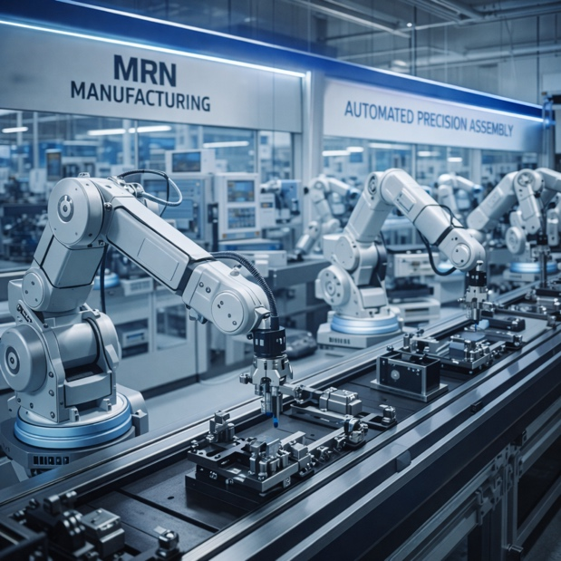
Task:
Give a five-minute talk on automation and the future of work in which you
- describe, compare and contrast the pictures above.
- analyze how automation and artificial intelligence are changing the world of work.
- discuss what skills will be most valuable in an automated future.

Part 2 — Paired Activity
Task:
Your school is organizing a "Future of Work" career day for students. With a partner, plan which sessions to include. Discuss the options below and agree on three:
- Workshop on AI and machine learning basics
- Panel discussion with professionals whose jobs have been transformed by technology
- Hands-on robotics demonstration and coding activity
- Presentation on "soft skills" that AI cannot replace
- Career counseling session focusing on future-proof professions

TASK SET A2: Healthcare Technology — High-Tech vs. Human Touch

Part 1 — Individual Long Turn

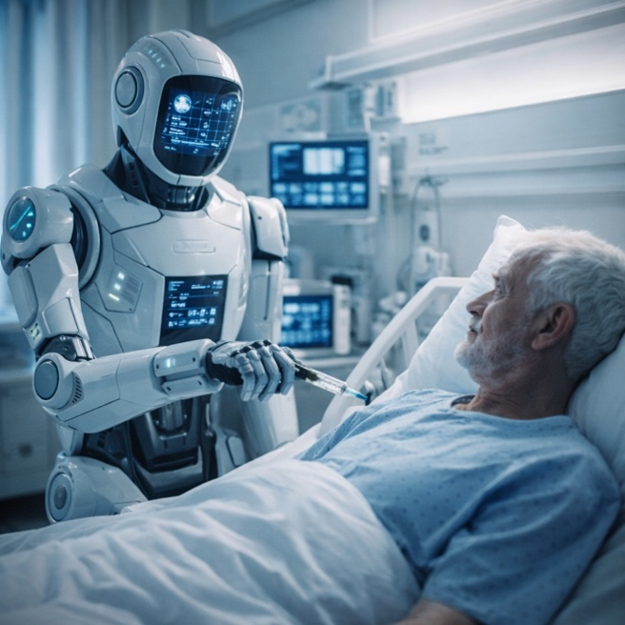

Task:
Give a five-minute talk on technology in healthcare in which you
- describe, compare and contrast the pictures above.
- evaluate the advantages and disadvantages of high-tech medical care versus traditional patient-doctor relationships.
- discuss whether technology in healthcare improves or diminishes the patient experience.

Part 2 — Paired Activity
Task:
You are volunteering at a local hospital. The hospital director wants student input on how to balance technology with personal care. Discuss the following aspects and agree on three priorities:
- Training staff to explain technology to anxious patients
- Ensuring doctors have time for personal conversations despite digital demands
- Using AI diagnostics while maintaining human oversight
- Creating comfortable, less clinical-looking treatment rooms
- Offering patients choice between high-tech and traditional treatment approaches

TASK SET A3: Technology's Double Edge — Connection vs. Isolation

Part 1 — Individual Long Turn



Task:
Give a five-minute talk on technology's impact on family relationships in which you
- describe, compare and contrast the pictures above.
- analyze how technology can both connect and isolate people within families.
- comment on your experience with technology in family settings.

Part 2 — Paired Activity
Task:
Your class is debating whether smartphones should be banned during family meals and gatherings. Take opposing positions and discuss:
- The importance of "unplugged" quality time for family bonding
- Situations where phones might be necessary (emergencies, including distant relatives)
- Whether banning creates conflict or teaches healthy habits
- Alternative compromises (designated phone-free times, device baskets)
- How different generations view phone use at gatherings

CATEGORY B: QUOTES

TASK SET B1: Artificial Intelligence — Promise and Peril
PART 1 — Individual Long Turn
Quote 1:
"I am an optimist and I believe that we can create AI for the good of the world. That it can work in harmony with us. We simply need to be aware of the dangers, identify them, employ the best possible practice and management, and prepare for its consequences well in advance."
— Stephen Hawking, Web Summit conference, Lisbon, November 2017
Quote 2:
"Success in creating AI would be the biggest event in human history. Unfortunately, it might also be the last, unless we learn how to avoid the risks."
— Stephen Hawking, The Independent, May 2014
Task:
Give a five-minute talk on artificial intelligence ethics in which you
- analyze and compare the two quotes above
- discuss the potential risks and benefits of artificial intelligence
- evaluate whether AI development should be accelerated, regulated, or slowed down.

Part 2 — Paired Activity
Task:
Your school wants to develop guidelines for AI use by students and teachers. Working with an ethics advisor, discuss the following aspects and agree on three priorities:
- Rules about using AI for homework and assignments
- Training teachers to recognize AI-generated work
- Teaching students about AI capabilities and limitations
- Policies on AI tools for students with learning differences
- Guidelines for using AI ethically while developing original thinking

TASK SET B2: Technology's Role in Human Life

Part 1 — Individual Long Turn
Quote 1:
"Any sufficiently advanced technology is indistinguishable from magic."
— Arthur C. Clarke, Profiles of the Future (1973)
Quote 2:
"Technology is just a tool. In terms of getting the kids working together and motivating them, the teacher is the most important."
— Bill Gates, The Independent on Sunday, October 1997
Task:
Give a five-minute talk on technology's role in human life in which you
- analyze and compare the two quotes above
- discuss examples of technology that seemed "magical" when first introduced but is now considered normal.
- comment on whether technology serves humans or controls them.

Part 2 — Paired Activity
Task:
Your school is organizing a "Tech for Good" exhibition to showcase positive uses of technology. Discuss which displays to include and agree on three:
- Medical technology saving lives (prosthetics, diagnostics, telemedicine)
- Environmental monitoring and climate solutions
- Educational apps and accessibility tools for students with disabilities
- Communication technology connecting refugees with families
- Agricultural technology helping farmers increase yields sustainably

CATEGORY C: ALTERNATIVE PROMPTS

TASK SET C1: The AI Generation Gap in Education
PART 1 — Individual Long Turn
Text Extract:
THE AI REVOLUTION IN STUDENT LIFE
Student adoption of AI tools has exploded. According to the Higher Education Policy Institute (HEPI) AI Survey 2025, 92% of British students now use AI in some form, up from just 66% in 2024. Even more striking, 88% of students now use generative AI specifically for assessments — compared to only 53% the year before. Meanwhile, only 56% of EU citizens possess basic or above-basic digital skills, and just 13.5% of EU enterprises actively use AI technologies. This creates a significant generational divide: students are racing ahead while institutions struggle to keep pace.
Sources: HEPI AI Survey 2025, Digital Education Council Global Survey 2024, Eurostat 2023-2024
Task:
Give a five-minute talk on AI in education in which you
- explain what the statistics reveal about AI adoption.
- analyze why students have adopted AI so quickly while institutions and businesses lag behind.
- discuss whether this gap is a problem and suggest solutions.

Part 2 — Paired Activity
Task:
Your school is conducting research on AI use among students. You have been asked to suggest priority research questions. Discuss the following and agree on three:
- How do students actually use AI tools — for learning, or just for shortcuts?
- What skills are students gaining or losing through AI use?
- How should teachers adapt their teaching methods and assessments?
- What are the mental health effects of constant AI assistance?
- How can schools prepare students for AI-integrated workplaces?

TASK SET C2: Jobs of the Future — AI Transformation
PART 1 — Individual Long Turn
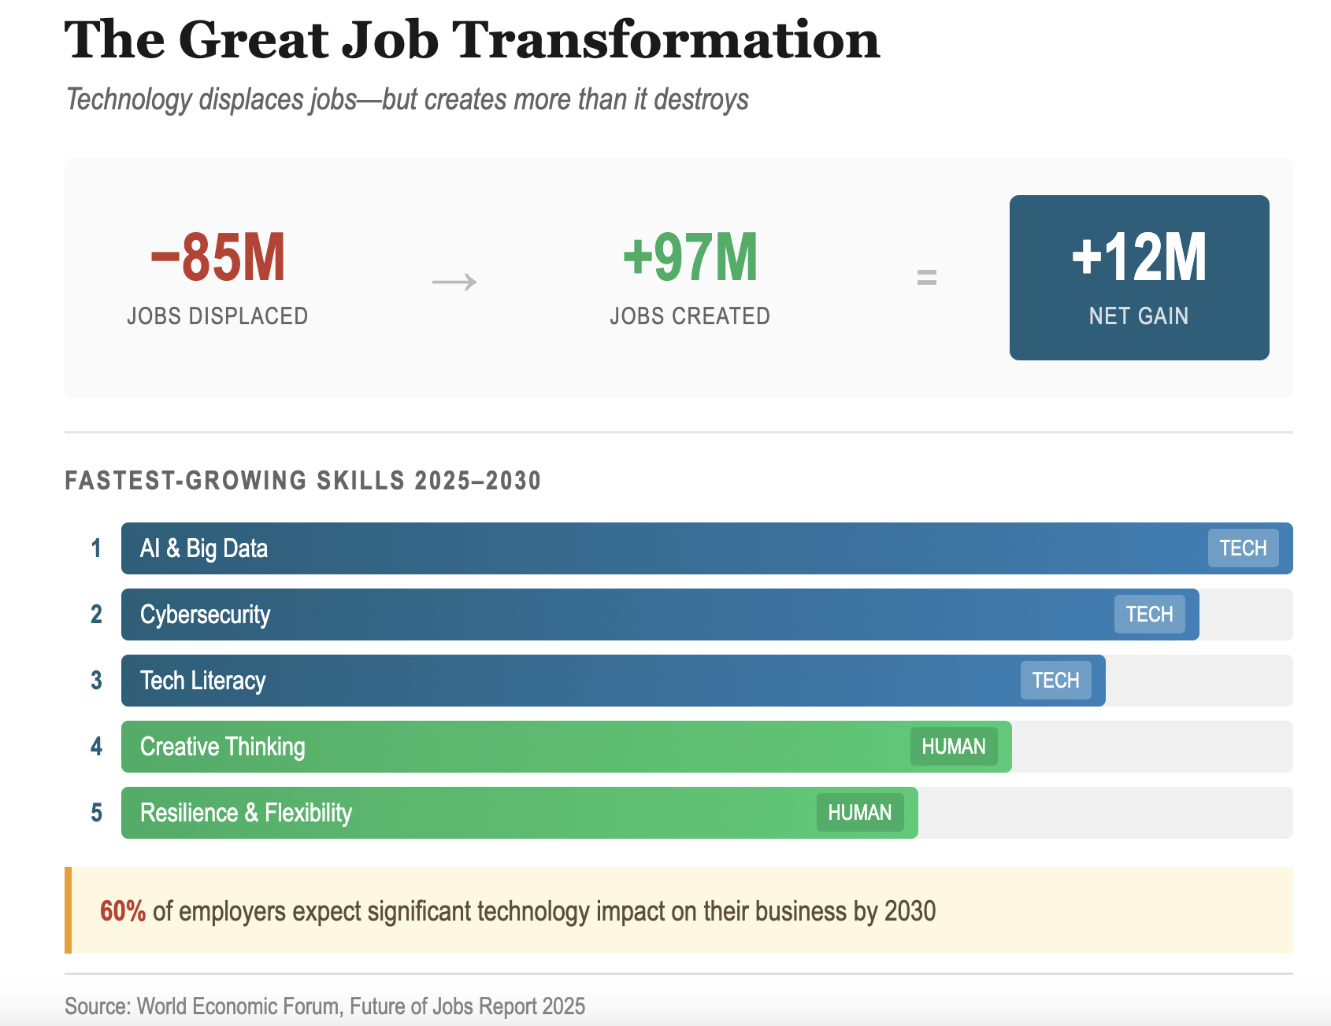
Task:
Give a five-minute talk on the future of work in which you
- analyze what the data reveals about future employment.
- discuss why certain skills are becoming more valuable for careers.
- evaluate whether the net job gain is reassuring or misleading.

Part 2 — Paired Activity
Task:
Your school is launching a "Future-Ready Skills" workshop series for students. Discuss which workshops to offer and agree on three:
- Introduction to AI tools and machine learning basics
- Digital security and online safety essentials
- Creative problem-solving and design thinking
- Communication and teamwork in digital environments
- Adaptability training: Learning how to learn

